Appendix F: Design Process Drawings and Sketches

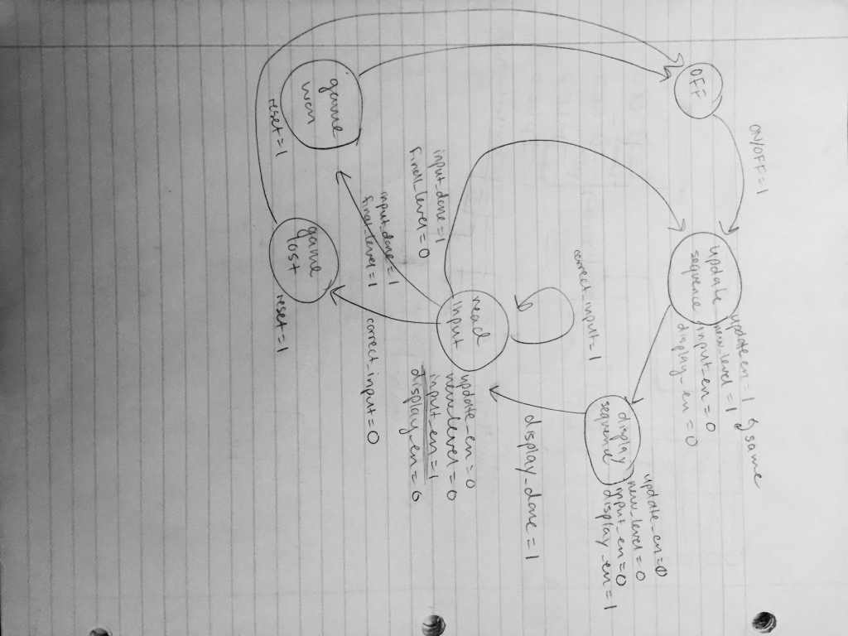

Figure 1. Original state machine diagram

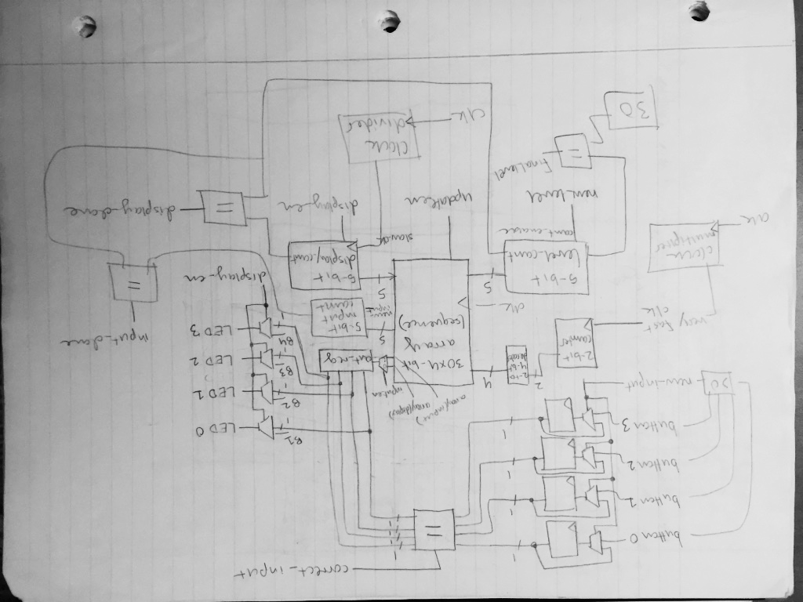

Figure 2. Original datapath diagram

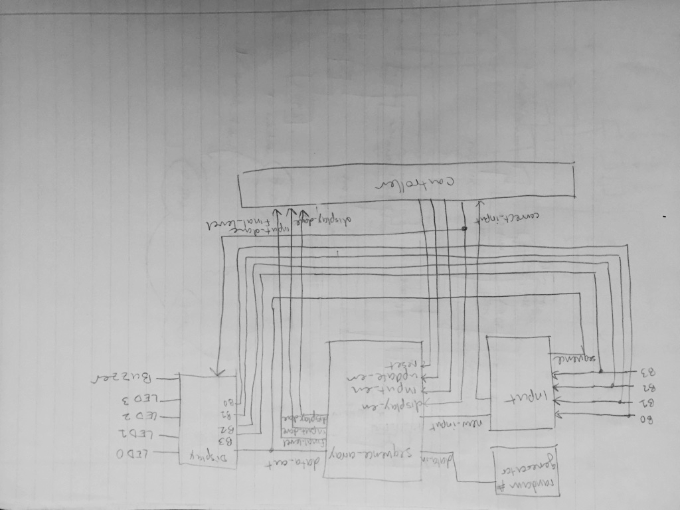

Figure 3. Original module-split design

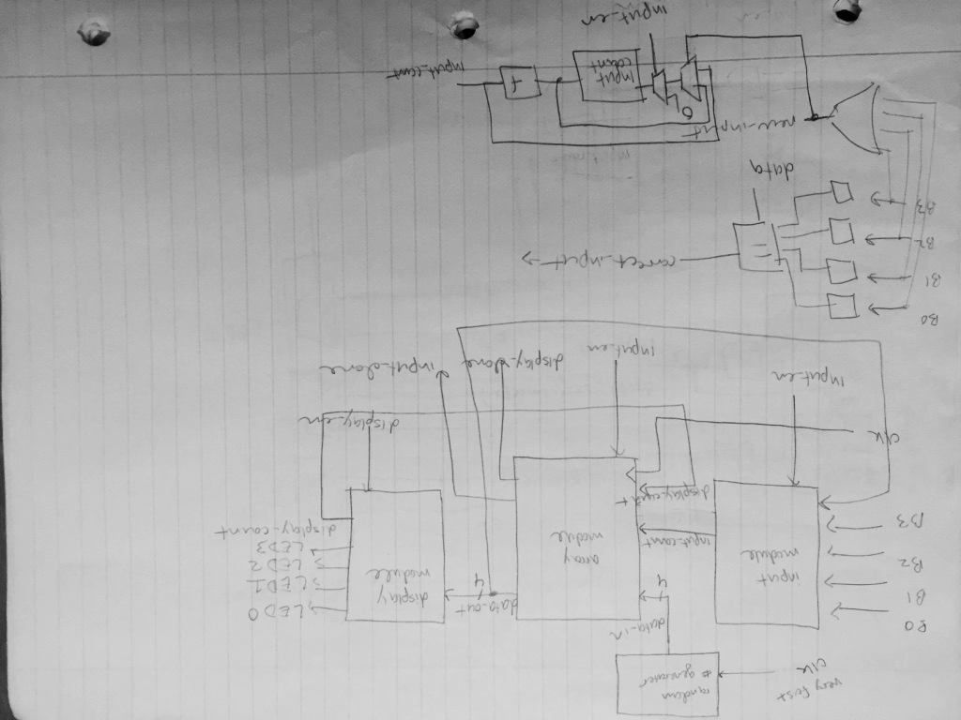

Figure 4. Iteration on top-level design (top), plan for Input Module (bottom)

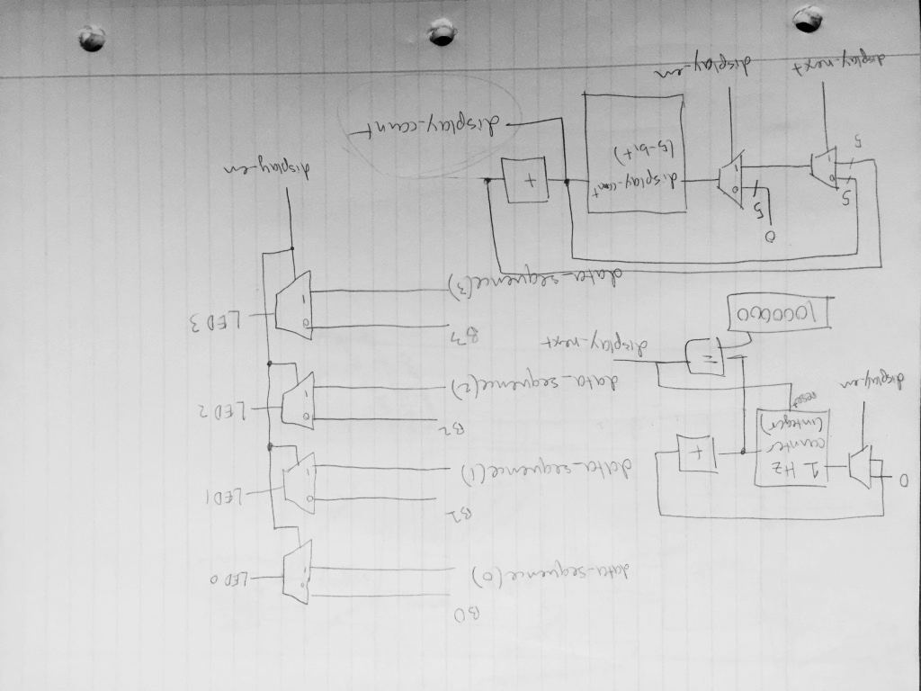

Figure 5. Original plan for Display Module datapath

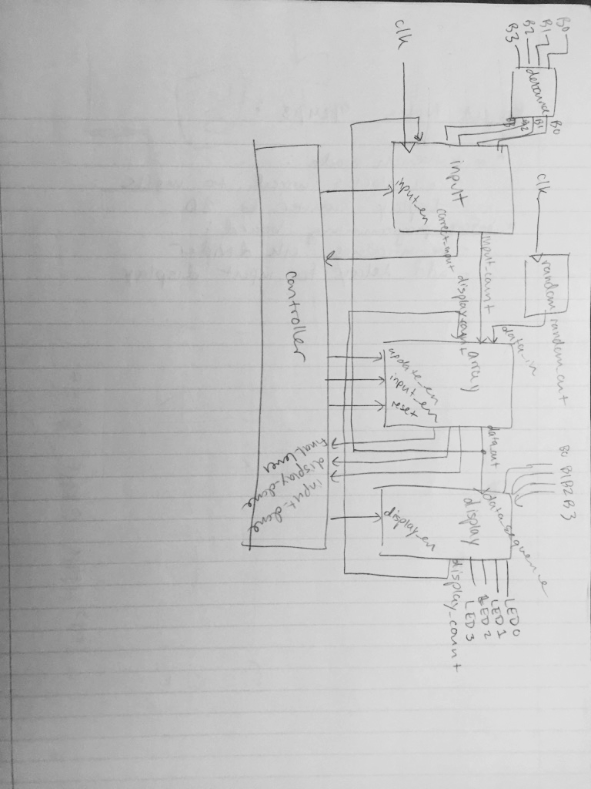

Figure 6. Iteration on top-level design

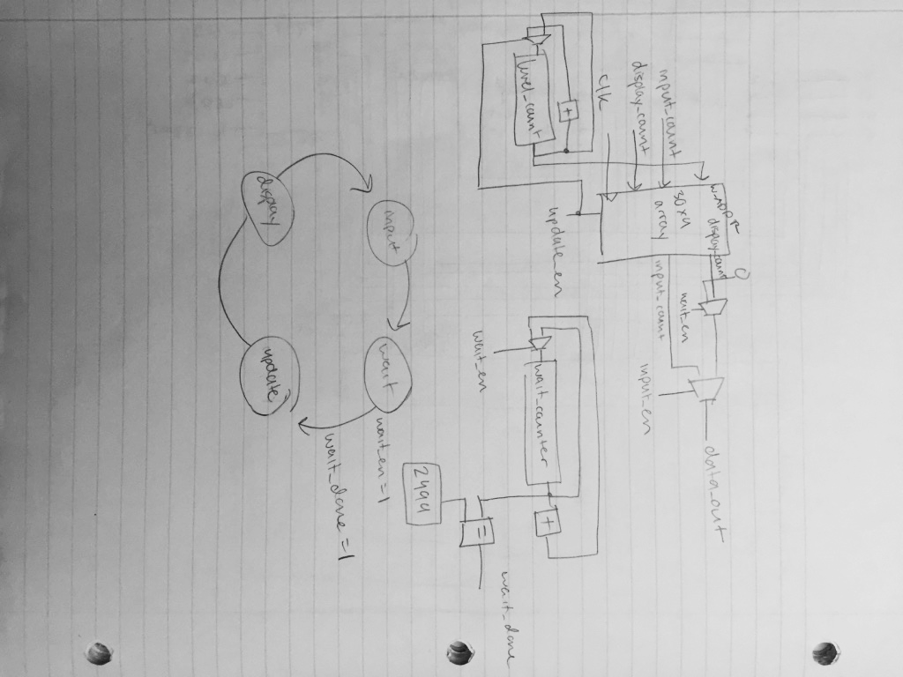

Figure 7. Plan for ‘waiting’ state (state diagram and datapath integration)

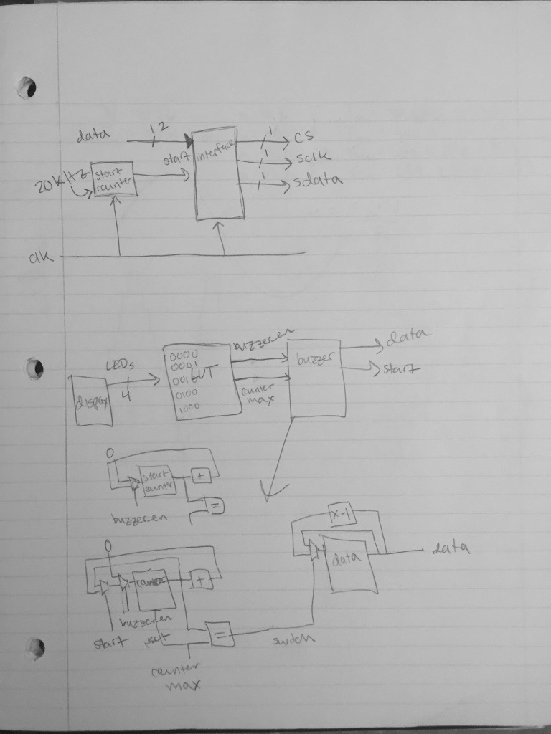

Figure 8. Plan for buzzer functionality

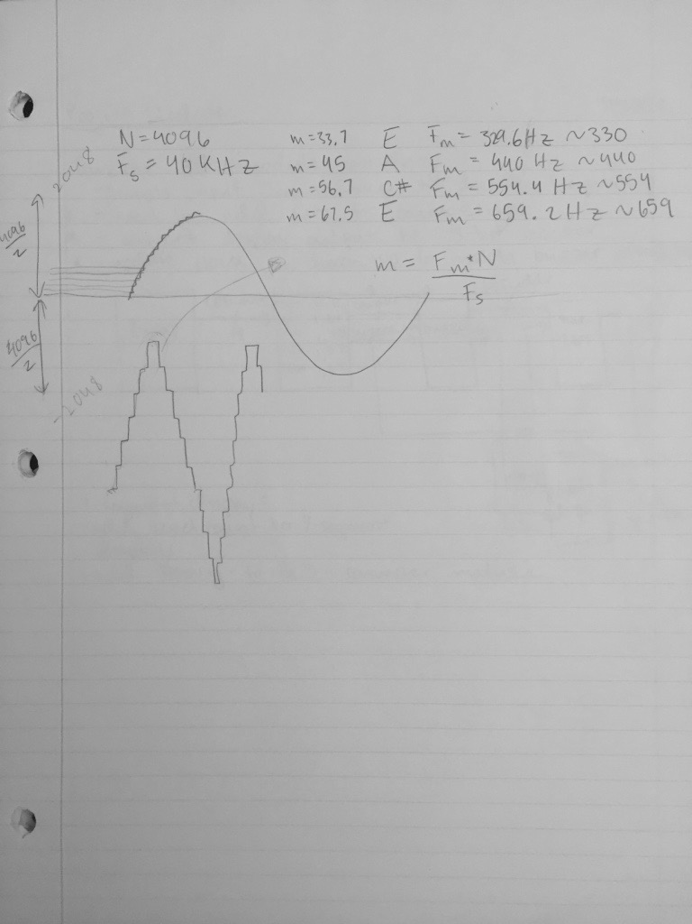

Figure 9. Calculations of counter step-sizes to achieve desired frequency

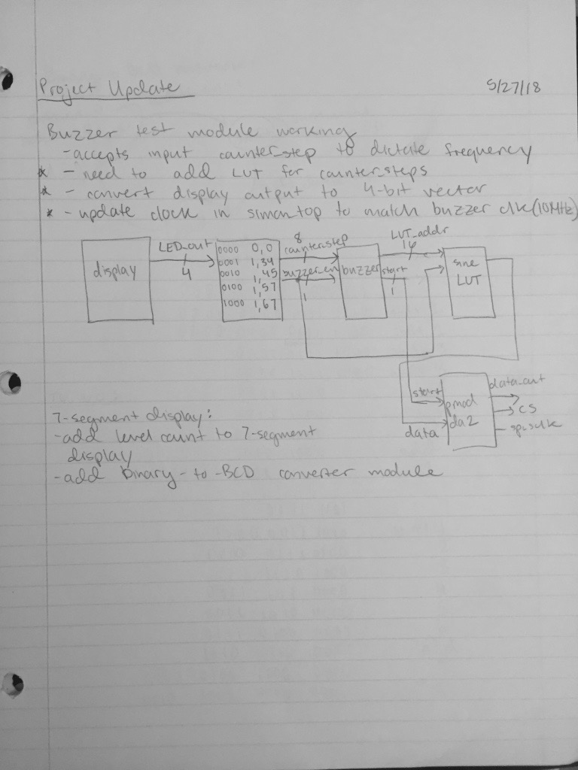

Figure 10. Integration plan for Buzzer Module